Explain what happen between 0 and 1

1. Sum of natural number from 0 up until N; Is the average of the number N and its square

And this is the shape of the sum of all natural numbers 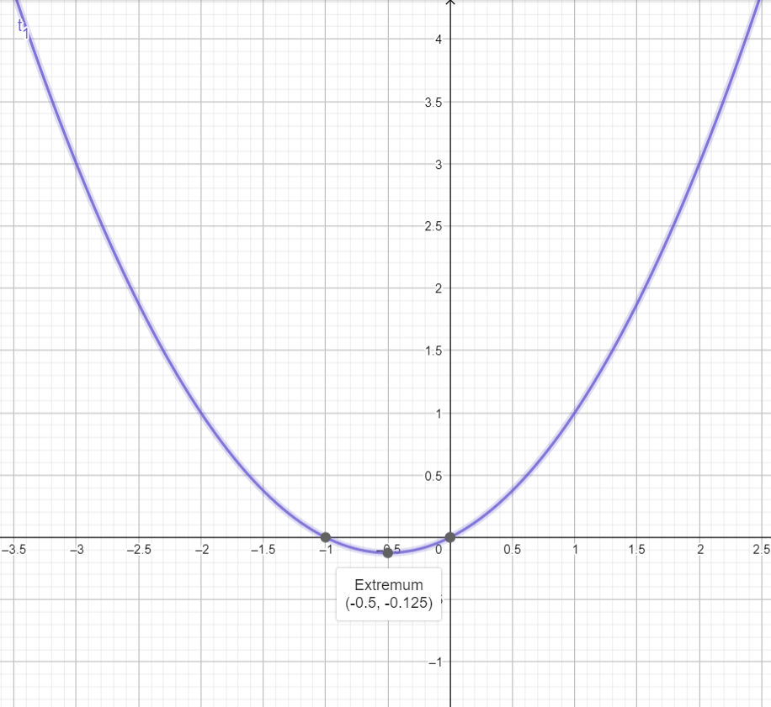

If you took any point on this curve will be the sum of all numbers from zero until this number N. 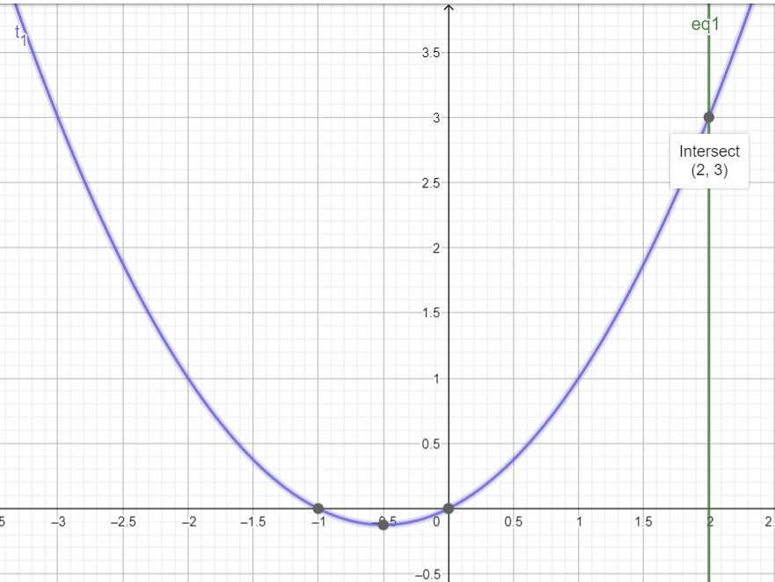

Ok so what about the sum of real numbers not on this curve?

{1/2 , 1/3 ,1/4 ,1/5 ,1/6 ,….}

Is the sum of all real numbers from 0 until 1.5 = 1.875?

Or 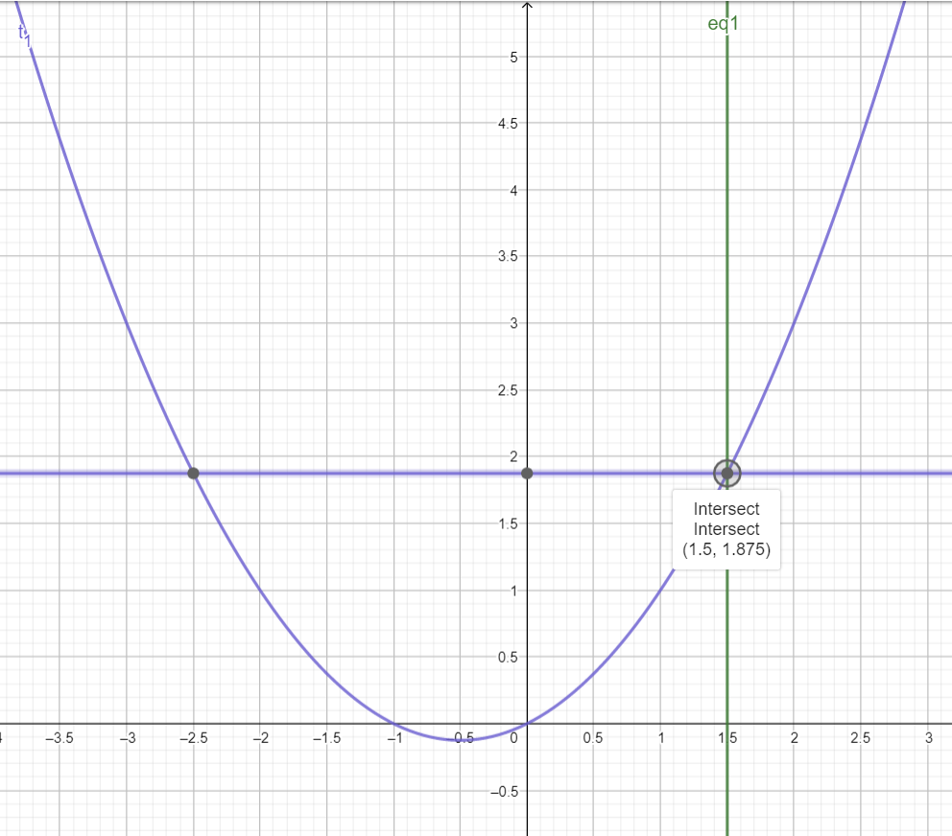

Or why at X =0.5 if we assume that this is the first real number why the point on the curve is 0.375?

It should be 0.5 but it is 0.5 + 1/6 = 0.375. so instead on being 4/8 = ½; It is 3/8 = 1/(2+2/3). Sum missing 1/8 until this point.

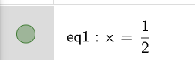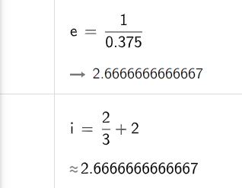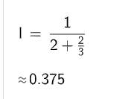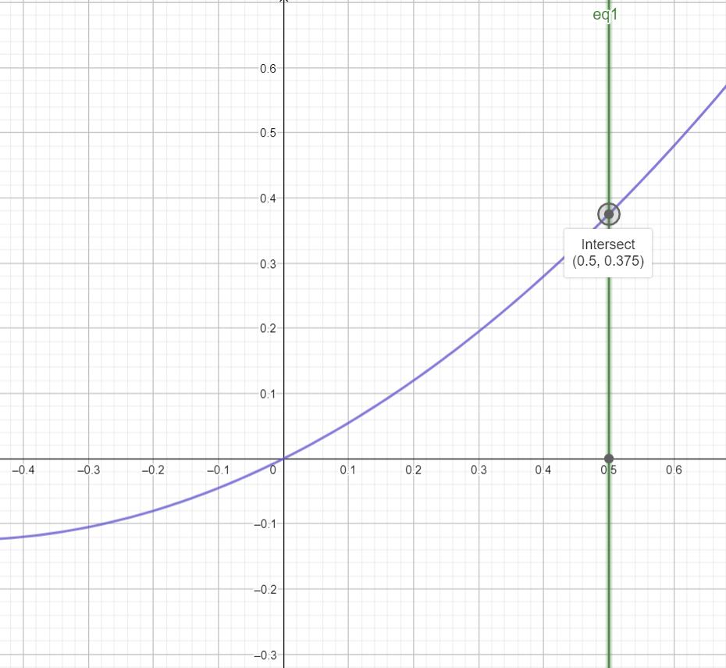

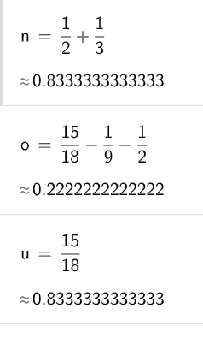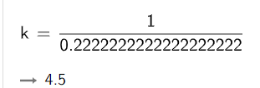Ok what about x = 1/3 the sum should be ½ +1/3 = 5/6 but it shows 0.22222222222222222 = 2/9 on sum curve; So instead of being 3/9 + 1/2 =1/3 +1/2 it is 2/9 so missing ½ and missing 1/9.

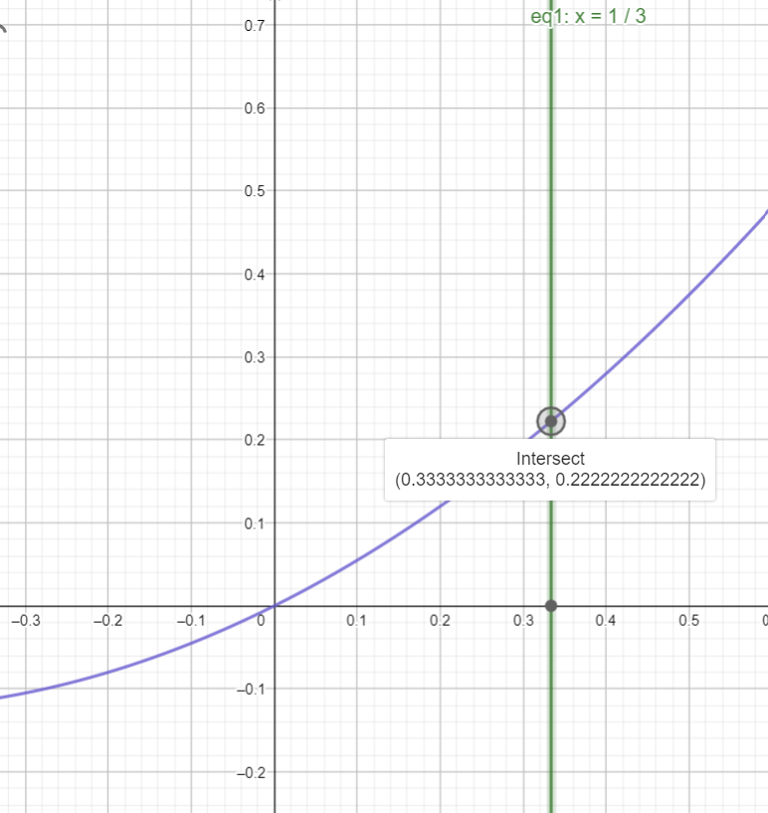

what about sum until ¼ sum(1/2+1/3+1/4) should be 13/12 but on the curve it is 0.15625

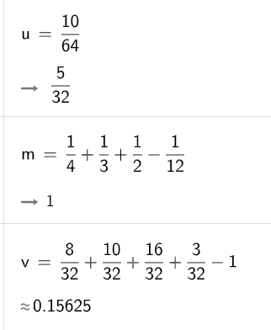

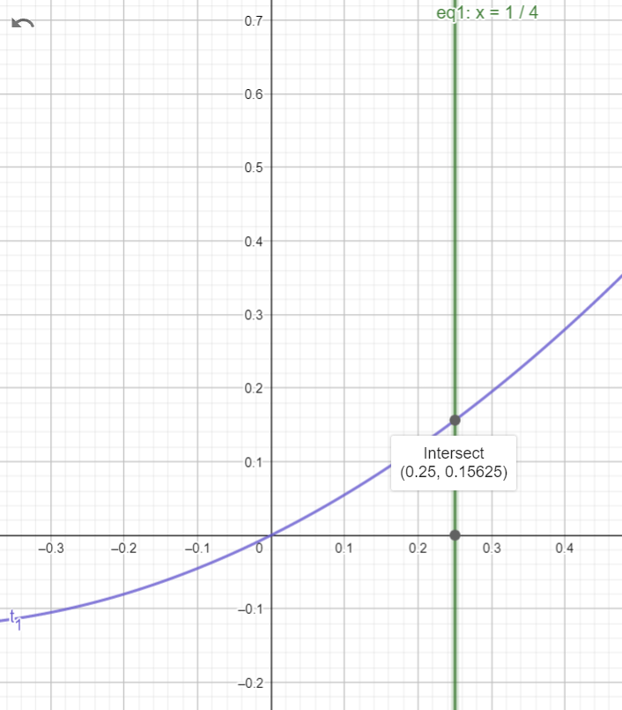

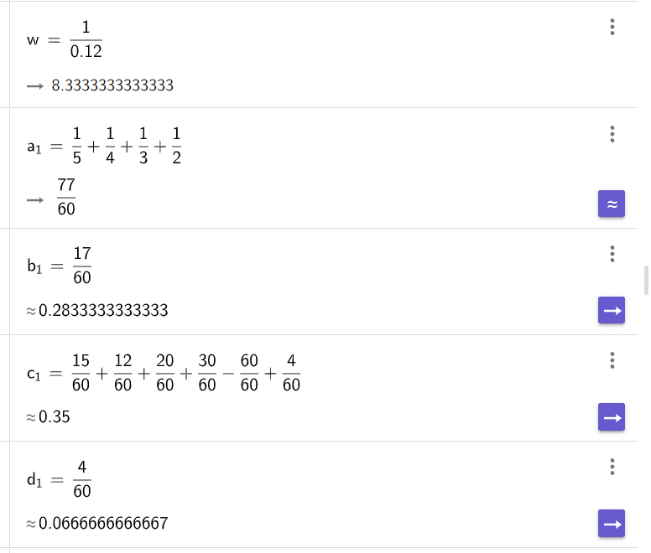

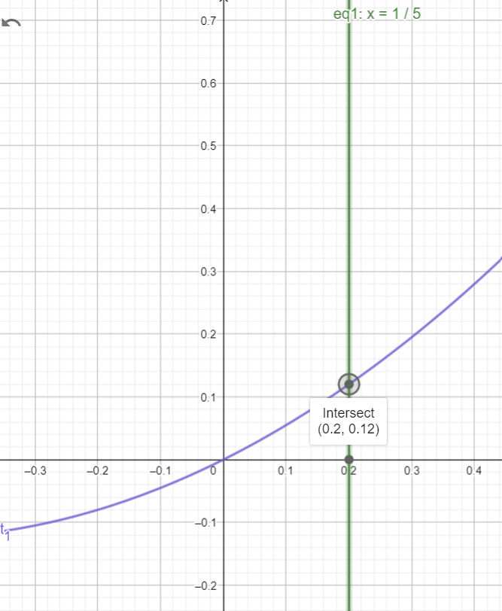

The sum of this set x = {1/2,1/3,/14,1/5,1/6,….} be for values for x between [0.5 , 0] on the sum curve.

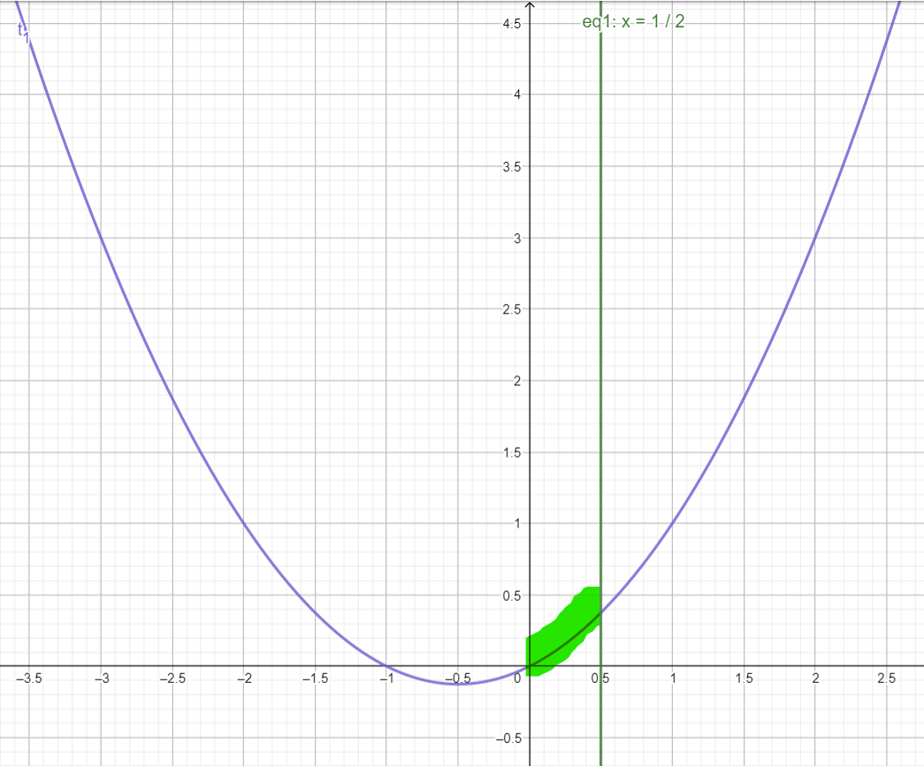

These lines for x = ½ and x= 1/3 and a= ¼ and x= 1/5 and x=1/6 …… all are values for x between [0.5 and 0] on the sum curve.

